How to deploy new CUI build to STG

1. Login machine “anintdep01.dev.activenetwork.com “ by remote desk top
2. Find target CUI version

1. Copy target CUI version to \\10.220.142.145\ActiveNetSites\_versions(report) \\10.220.142.145\ActiveNetACM\_versions(ACM)
2. Remote logon machine “10.220.142.145”
3. Run “DeployManager.exe” under path “E:\DMDE\CUIDeployer”, login with STG portal account

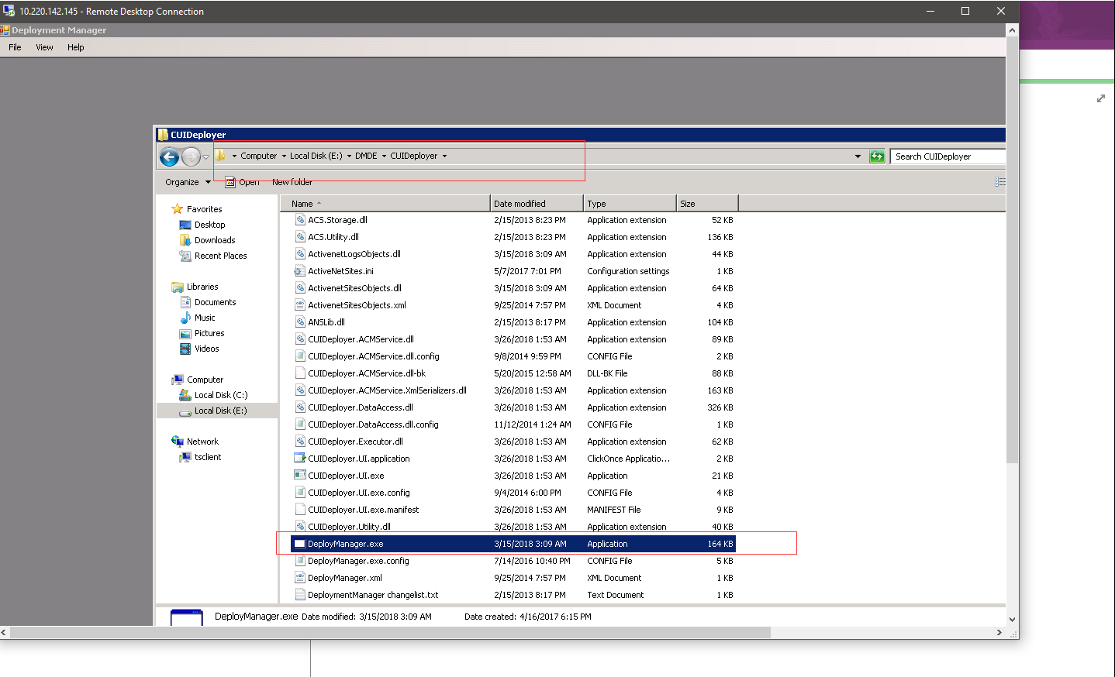

1. Search orgs, add org to where and select all paras

Search orgs by “pick specific sites”

Org selected then click “add to where?”

Click “deploy to CUI”

Choose target version

Not selected side A & side B

Then make all para selected

Create Batch 
Site Selection 
Production? 
Client Sites? 
Green Code? 
Special Handling? 
Deployed? 
Trainer Preview? 
From Version: 
To Version: 
Picked Sites 
Pick Specific Sites 
LSTGOneteamkids 
Operations Start Batch 
Deploy To: 
AUI 
Selected Operations 
copr VERSION 
OVERRIDE EXISTING 
UPDATE IIS 
CHECK DATA 
r-r¯r- 
C 
AngelEÄ. 
Web Pool 
Web Pool 
activenetstgl 
Unselect All 
dbstganetOI 
Where Clause 
(LIRL INCLSTGOneteamkids'l AND RETIRED = 
Check SOL 
Clear SOL 
chool, Istgsanjoseparksandr 
Sites Selected 
Set to Default 
Version : 
UPDATE SITE 
Add To Where? 
REGISTER PAGE TYPE 
UPLOAD TEMPLATE PACKAGE 
UPDATE SITE SETTINGS 
UPDATE 
UPDATE 
UPDATE 
PAGES 
PAGELETES 
MOBILE 

1. Change tab to start batch, input a name and click “Creat Batch”

i - Remote Desktop Connection 
Create Batch 
Site Selection 
Production? 
Client Sites? 
Green Code? 
Special Handling? 
Deployed? 
Trainer Preview? 
From Version: 
To Version: 
Picked Sites 
Pick Specific Sites 
LSTGOneteamkids 
Start Batch 
Operations 
Selected Sites 
LSTGOneteamkids 
Web Pool 
Web Pool 
activenetstgl 
Unselect All 
dbstganetOI 
Where Clause 
(LIRL INCLSTGOneteamkids'l AND RETIRED = 
r-r¯r- 
Sites Selected 
Sites Selec 
Check SOL 
Green? 
Clear SOL 
Web Pool 
Set to Default 
Current Ver 
Add To Where? 
Beta? 
Nam 
Start Time: 
sites selected 
Andrew Deploy perf cull 
Start in Paused state 
Servers: 
Select Server 
Create Batch 

1. Run “CUIDeployer.UI.exe” under path “E:\DMDE\CUIDeployer”
2. Check the branch name and start deploy

@Ctivedev03

#10.219.128.217

anintdep01.dev.activenetwork.com

10.220.142.145

dev\rcheng

dev\achen1